**"Village Scenario"**

**List of features:**

House, School, Railway Station, Tree, Hill, River, Sky, Overbridge, Rail Line, Boat, Cloud, Turbine, Day & Night View, Sun, Moon, Desert-View, Building, Plane, Road, Vehicle.

**Introduction:**

"Village 2.0: Where Tradition Meets Innovation" is an immersive computer graphics project that seamlessly combines traditional elements of village life with modern innovations. Through meticulous detailing and creative design, this project showcases the harmonious integration of a quaint village with a bustling city. By celebrating the essence of rural life while highlighting the coexistence of tradition and technology, this project serves as a visual narrative, inspiring viewers to appreciate the synergy between tradition and innovation for a brighter future.

**Literature Review:**

The revised project draws inspiration from existing research on rural-urban migration and the impact of infrastructure on community life. It builds on the idea of merging contrasting elements, as seen in various art and design disciplines that explore the juxtaposition of tradition and modernity.

**Objectives:**

* Seamlessly integrate traditional elements of village life with modern innovations through computer graphics.
* Showcase the coexistence of tradition and technology in a visually captivating manner.
* Showcase the evolving nature of rural communities and their connections to urban centers.
* Depict the role of transportation infrastructure in facilitating communication and exchange between villages and cities.
* Explore the interplay of tradition and modernity in a dynamic rural context.

**Methodology:**

The project involves the use of computer graphics tools and techniques to design and render various elements, including houses, schools, railway stations, trees, hills, rivers, skies, overbridges, rail lines, boats, clouds, turbines, day and night views, sun, moon, desert views, buildings, planes, roads, and vehicles. The addition of a city view showcases the expansion of the environment, introducing trains, roads, and vehicles. The desert view demonstrates the journey of the train from the village to the city, passing through the desert landscape.

**Significance of the Project:**

The "Village 2.0" project holds significance in several aspects:

* Cultural Preservation: The project highlights the importance of preserving traditional values and cultural heritage while embracing technological advancements.
* Rural-Urban Integration: By showcasing the journey of the train from the village through the desert to the city, the project emphasizes the integration of rural and urban environments.
* Technological Integration: It demonstrates the capability of computer graphics in seamlessly integrating traditional and modern elements, reflecting the potential of technology to bridge cultural gaps.
* Narrative Transition: The addition of a city view and a desert view introduces a narrative element, illustrating the journey of the train from the village, crossing the desert, and reaching the bustling city.

**Conclusion:**

"Village 2.0: Where Tradition Meets Innovation" is a computer graphics project that seamlessly combines traditional elements of village life with modern innovations. By presenting the journey of a train from a quaint village through a captivating desert landscape to a bustling city, this project emphasizes the coexistence of tradition and technology. Through meticulous attention to detail and visual storytelling, the project aims to inspire viewers to appreciate the synergy between tradition and innovation for a brighter future.

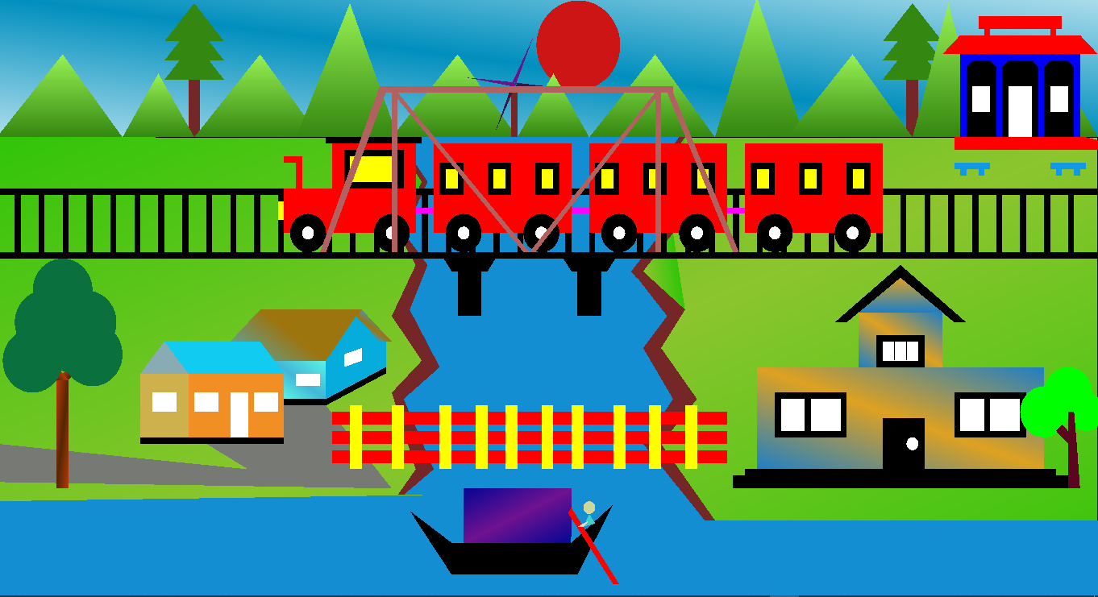

##Display 1

Monisha: House, Station, School.

Rohan: Train, Rail Line, Boat.

Joy: Day view, Movement (Train cloud Turbine)

George & Udai: Hill, Turbine Design, Tree, Grass, Overbridge, Sky view.

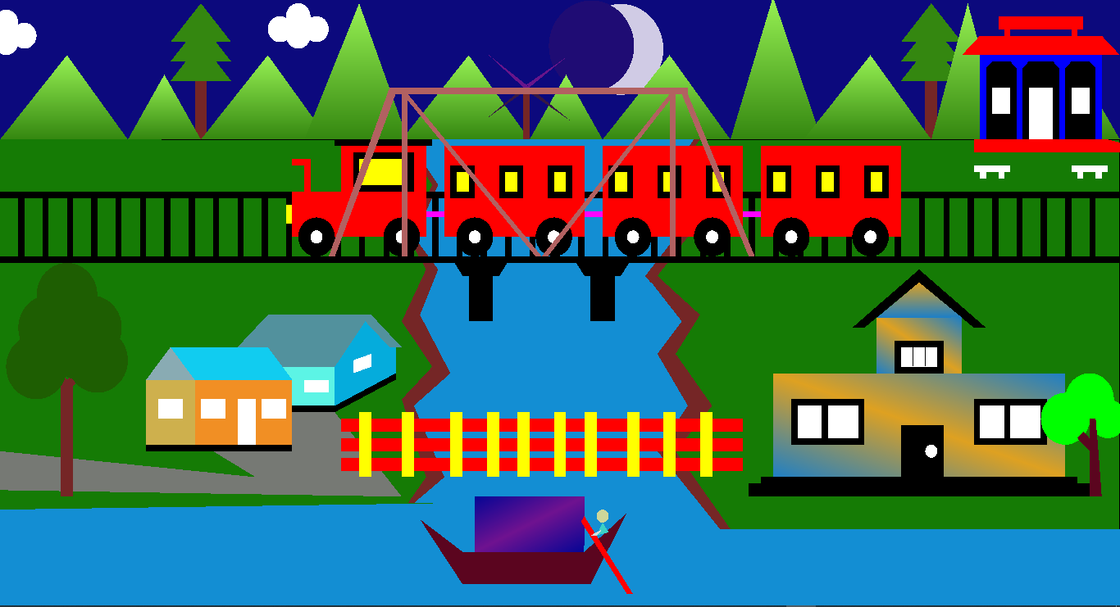

##Display 2

Monisha: House, Station, School.

Rohan: Train, Rail Line, Boat.

Joy: Night view, Movement (Train cloud Turbine)

George & Udai: Hill, Turbine Design, Tree, Grass, Overbridge, Sky view.

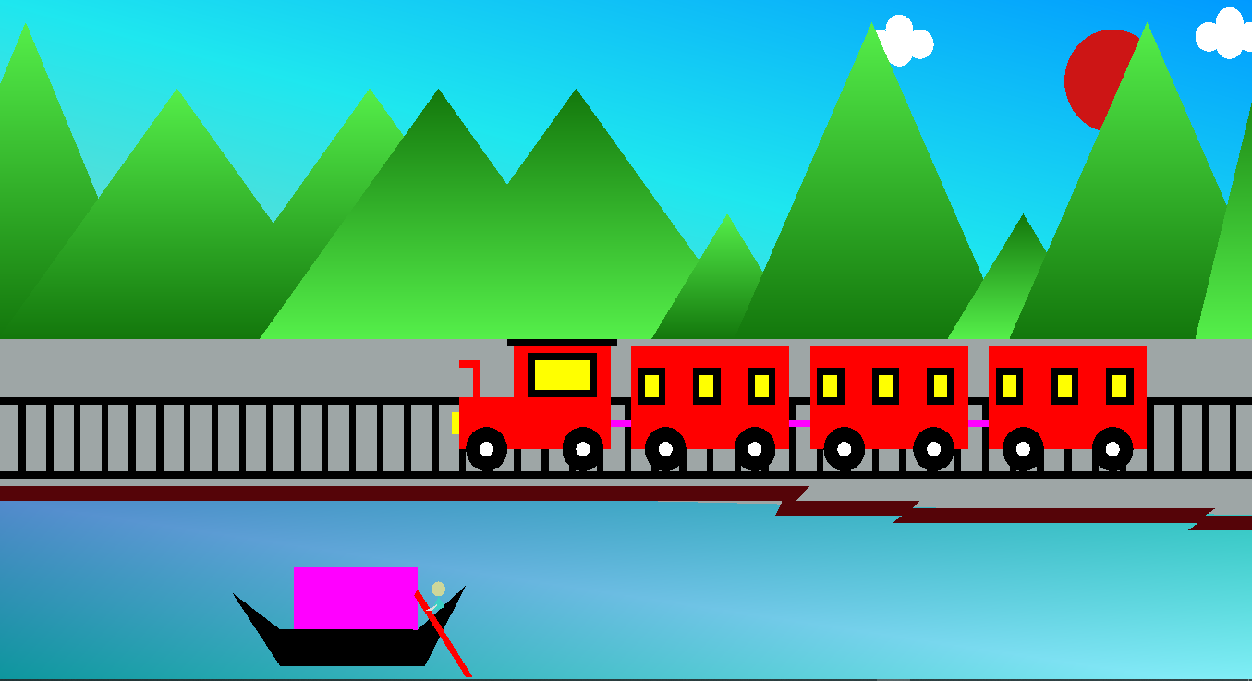

##Display-3

Monisha: Hill, Boat.

Rohan: Train, Rail Line

Joy: Movement (Train cloud Boat)

Udai & George: River, Sky View Design.

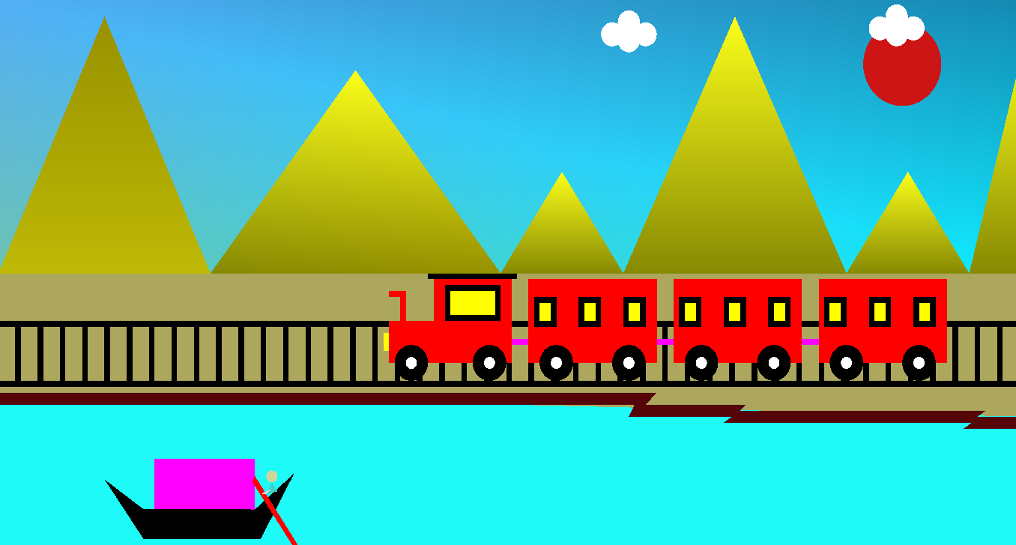

##Display-4

Monisha: Hill, Boat.

Rohan: Train, Rail Line.

Joy: Movement (Train cloud Boat)

Udai & George: River, Sky View Design.

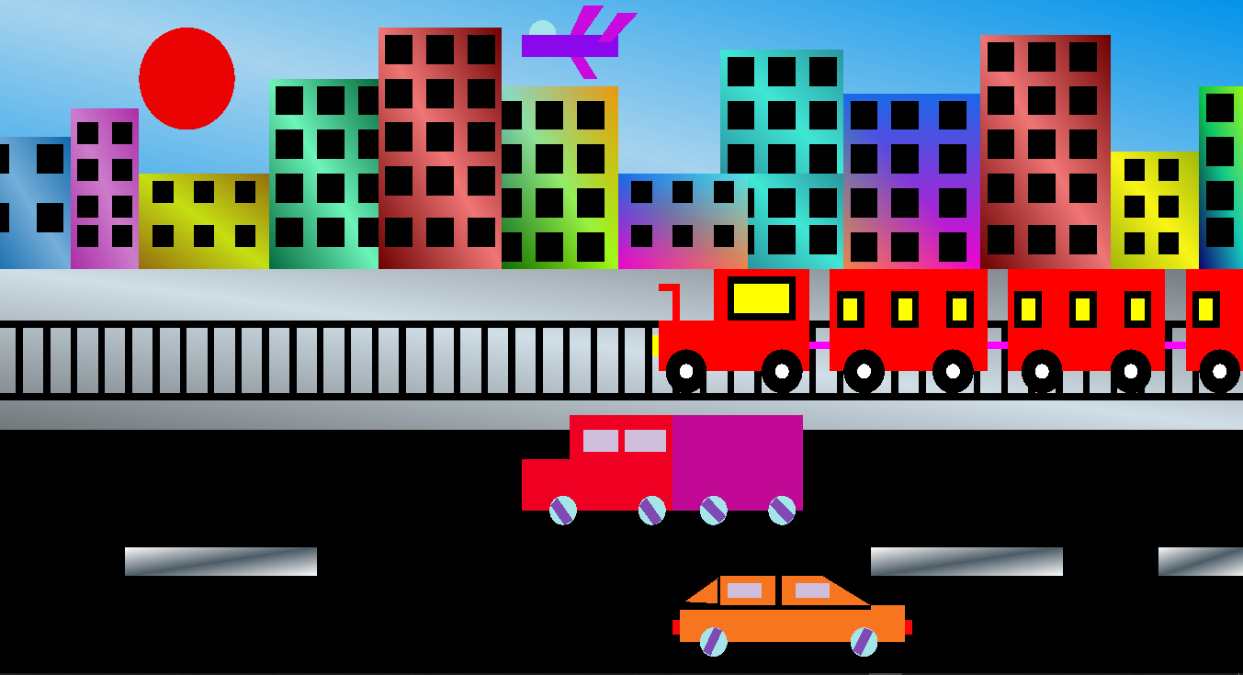

##Display-5

Monisha & Rohan: Building & Train.

Joy: Movement (Train cloud Vehicle)

Udai & George: Vehicle Design, Road, Sky.